L.A.R.S. Fox Hunt of 22 April 2006
By Peter Rock KJ4ND, the Hound

The weather for the fox hunt was better than predicted. Originally we were expecting rain, but the sky had cleared, and it turned out to be a good day for a hunt.
I arrived at the parking lot by the Tractor Supply close to 10 am. There was some church group selling something near by, so I parked over a little to give them some room.
I could not hear the fox at 10 am, and called out on the repeater (146.610). about that time another ham started a RACES net on the repeater, and was asking for check-ins. I believe his call was ky4rl. It did not last very long, and I could hear only one other ham replying, so I do not know if he was using our repeater deliberately, or if he was just incidentally getting into more than one repeater at the same time.
Anyway, no one else showed up, and Stan did announce that the fox was on. I just could not hear it there. So I drove up by that dentist office behind Wal-Mart's, and could hear it faintly from there, not even enough to see any signal strength bars on the HT. The heading from there was approximately east. I ended up driving along the 192 bypass, and stopped by the Library to get a reading there on a hill there. It was stronger there, and I got a reading to the South. So I got back in the minivan and headed over by the flea market. It was not very strong there. And I tried another reading which was weak and to the East. In retrospect, There was probably a hill in the way, and I was getting a reflection, although I did not think so at the time. Jim N4ICU and Stan KD4ERF both came by about then and offered encouragement. Looking at the map I was not sure which way to go, since the last direction had no direct road to it.
So I headed south, and fortunately the signal got stronger, and I stopped at the softball fields across from Levi Jackson Park to get a reading. I got a definite strong reading across toward the park. So I headed over that way, and it got even stronger, and got out on foot in the main picnic area. I could even hear it with the HT with the antenna off. So I thought it had to be very close. But I tried several times to find it and moved a couple times, and got some reflections at times (2 or more directions of almost the same signal strength.).
When I tried one new one it got very strong and I ended up by this fallen tree. And knew I had to be within a feet of it, but could not see it. I looked up in the roots and though it could be in one of those holes there. There were a lot of thick leaf piles there, but did not look like any were disturbed. Finally I brushed the leaves with my feet, and found the fox.
It was hidden very well. So another interesting hunt was concluded, and I am looking forward to the next one.

73's Peter kj4nd

NOTE: SEE THE NEXT PAGE FOR PICTURES OF THE FOX HUNT….

Pictures of the Fox Hunt of Saturday, April 22, 2006
Pictures compliments of Stan KD4ERF

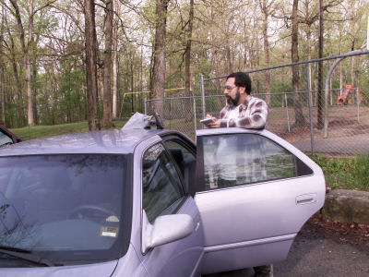

1. Jim Russell N4ICU, a.k.a., “the sneaky fox”, makes notes of the fox location using the GPS and checks out the health of the fox prior to concealing it in a nearby lair.

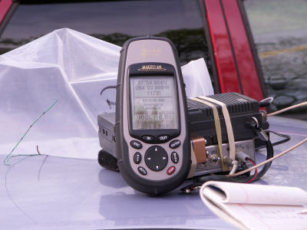

2. The GPS reveals the location of the fox for use with the maps of the area. Characteristics of the radio frequency signals from the location are noted for use in the future.
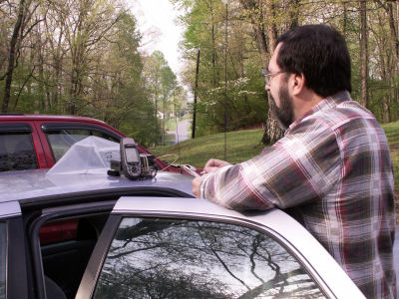

3. Jim N4ICU records information on the site for future reference.

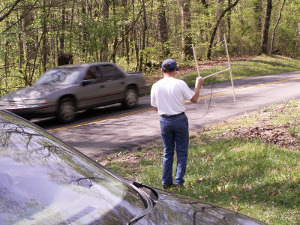
- Peter Rock KJ4ND uses a home brew antenna to try to get a direction on the fox signal.

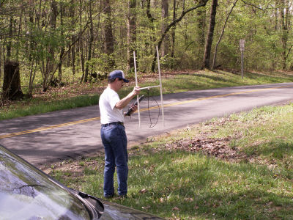

5. Peter KJ4ND seems to have narrowed the direction of the fox as the attenuator shows a very strong signal.

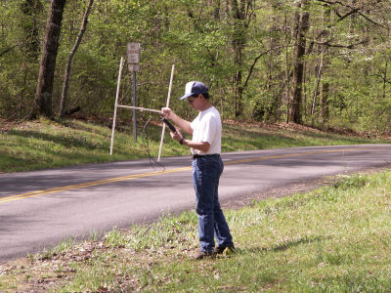

6. Peter KJ4ND turns in all directions to find the direction with the strongest signal.

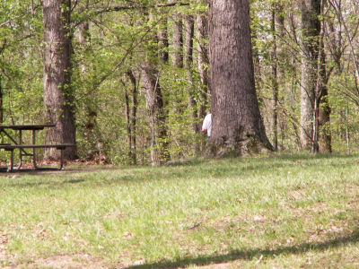

7. Peter KJ4ND disappears into the undergrowth in the park looking for the fox.

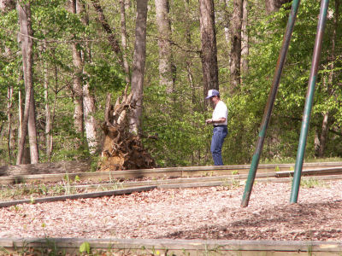

8. Peter KJ4ND seems to have a very strong signal coming from a fallen tree.

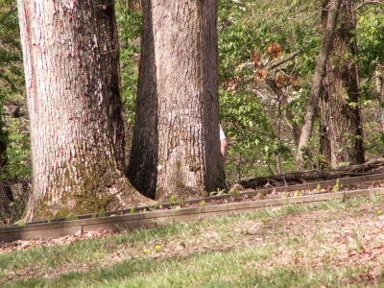

9. Peter KJ4ND disappears behind a tree near the fallen tree.

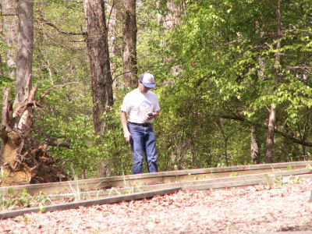

10. Peter checks the fallen leaves in the area around the tree stump, hoping to find the fox.

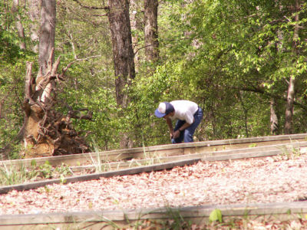

11. Peter KJ4ND looks in some holed under the tree stump, fearing that something besides the fox could be lurking in the holes.

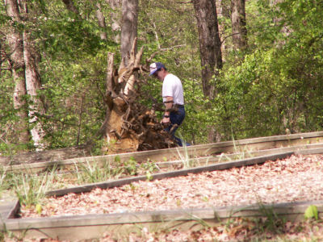

12. Peter KJ4ND, confident that the fox is in the immediate vicinity, uses his foot to clear out the dead leaves, and finds the sneaky fox.

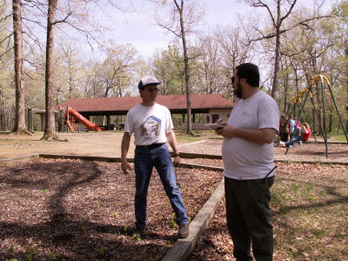

13. Peter KJ4ND discusses the problems in the hunt with Jim N4ICU.

